Headphone amplifier test
22/06/2025
Nick Schneider

This is a single-supply, op-amp–based headphone amplifier designed to let an electric guitar be heard through 32 Ω wired headphones at an appropriate volume and with minimal distortion. The primary design goals were:
- To amplify a passive electric guitar signal without tone loss
- To drive low-impedance headphones cleanly from a 9 V power supply on a pedalboard
- To fit all components within a pedal-style enclosure using common parts
- Include LTspice testing and iterations

Things to consider:
- Output of an electric guitar is a high impedance signal. Impedance matching will be necessary on the input of the circuit. Guitar output levels are unbiased (centred around 0V) and vary wildly. It’s important to leave headroom to prevent clipping.
- Headphone input impedance can vary greatly from 35 Ohms to 600 Ohms and also require an unbiased signal.
- It can be easy to ruin equipment and hurt ears. Things like output resistors and capacitors to clean DC will help.
- OP-amps are stacks with tiny electronics and are prone to breaking. When it’s time to solder onto your PCB’s consider using an IC socket to make swapping out your IC’s easier.
- Human hearing is logarithmic — we perceive equal ratios (not equal steps) in volume. Consider using logarithmic potentiometers for smoother, more natural-feeling volume control.

First Iteration 22/06/2025
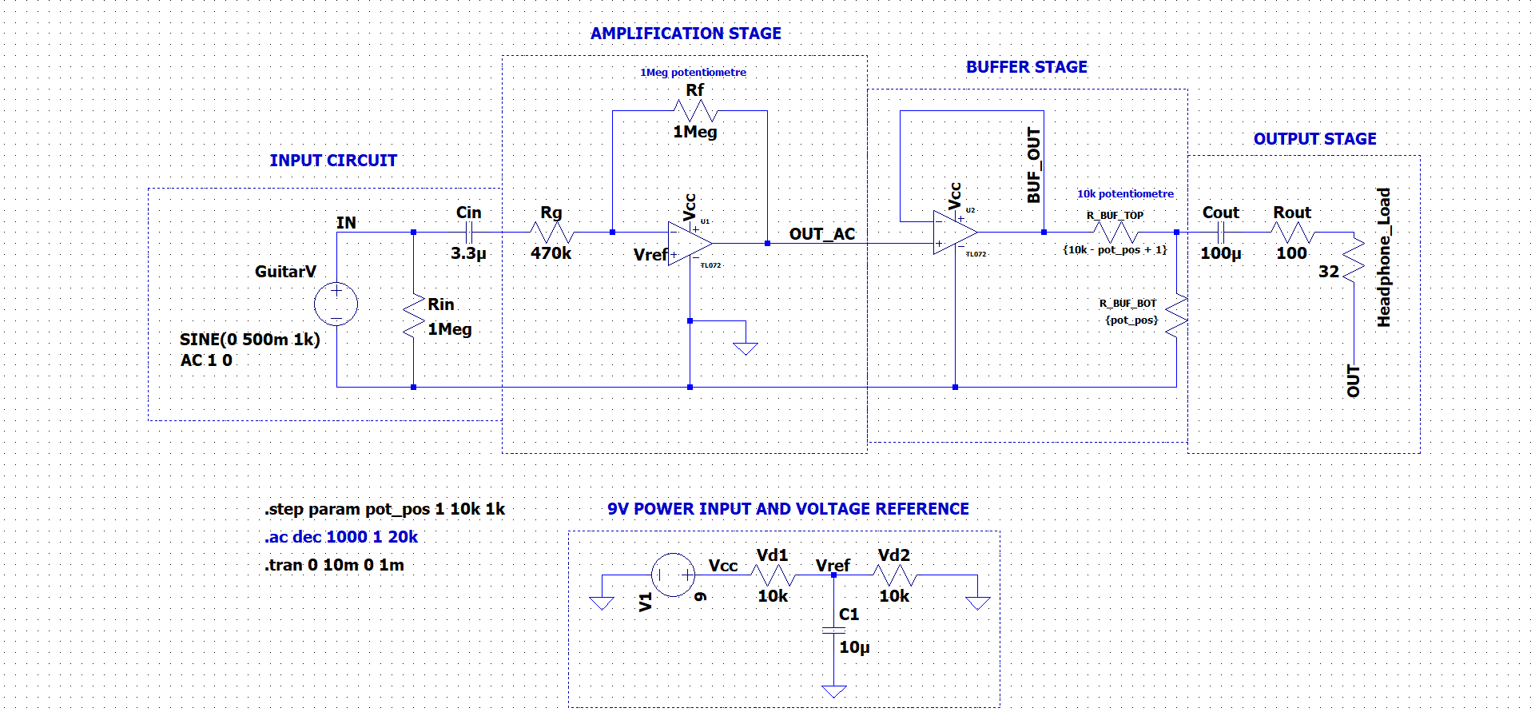

The general idea of this model is to make an electric guitar pre-amp + headphone amp that can be run off a pedal board 9V supply.
Power Input and Voltage Reference
The op-amps are powered from a 9 V DC supply, like a typical pedalboard. A virtual ground (Vref = 4.5 V) is created using the 2 x 10k resistors creating a voltage divider and bypass capacitor, providing the DC bias reference for all op-amp stages. This allows the circuit to operate as if it's dual-supply, even though it's powered by a single 9 V rail.
Input Stage
- The guitar input is AC-coupled via a 3.3 µF film cap to block any DC from external sources.
- A 1 MΩ resistor to ground ensures the circuit presents a high input impedance, suitable for passive pickups
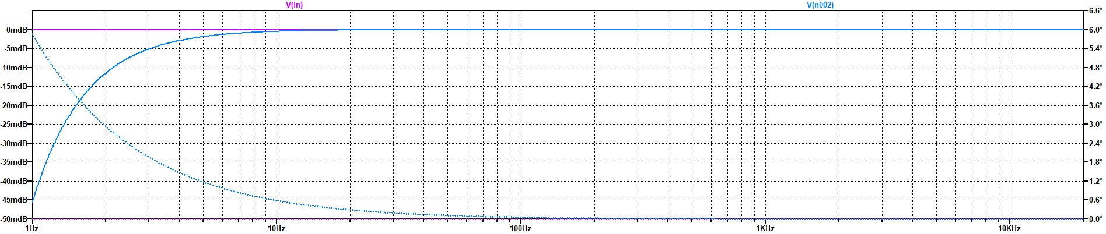
Pickup output levels can greatly vary depending on the make of pickup. It’s not unknown for humbuckers or other active pickups to reach an output of 1Vpp. The guitar voltage input simulates a strong passive pickup output at 500mV. The guitar used for testing is a Fender Strat with standard humbuckers on the bridge and 2 single coils in the middle and neck pickup positions.
1: Frequency response after Cin in the Input circuit stage
The 3.3uF Cin input capacitor rolls the signal off -3mdB at ~4Hz which effectively doesn’t affect the output sound. Later iterations of the design might implement a stronger roll-off to cut out potentially unwanted low-end frequencies. The higher the capacitance, the steeper the roll-off and the higher the roll-off begins.

Amplification Stage
The first op-amp in the TL072 is configured as a non-inverting amplifier, with:
- Rg = 470 kΩ
- Rf = 1 MΩ potentiometer
- Gain ≈ 3.13×
$$Gain (G)=1+\frac{R_{f}}{R_{g}}$$
So the max is essentially a gain of +3.13 which is around a +6db increase in amplitude.
This configuration boosts the instrument-level signal (~100–500 mV) to line/headphone level while maintaining signal fidelity. It's biased at 4.5 V (Vref) to allow full swing in a single-supply configuration.
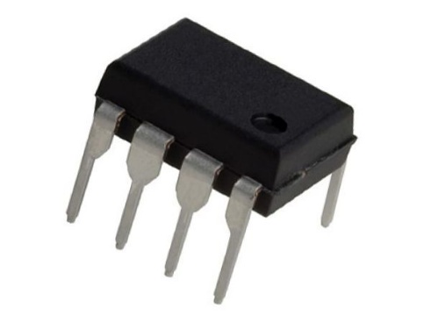
TL072 Low-Noise FET-Input Operational Amplifier
Spice asy file
https://ltwiki.org/index.php?title=File:TL072.asy

Spice sub file
https://ltwiki.org/index.php?title=File:TL072.sub

Datasheet
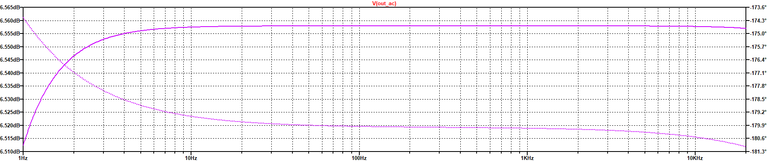
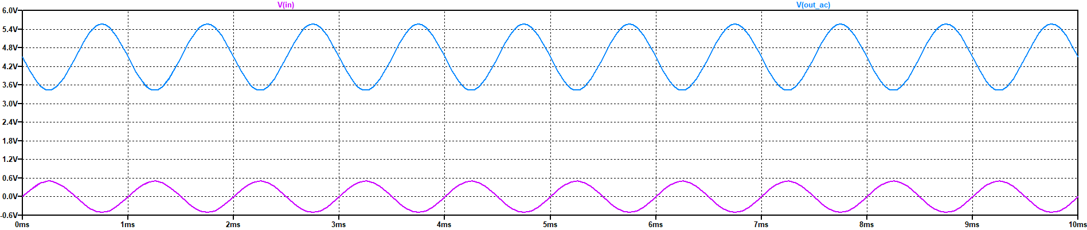
https://www.ti.com/lit/ds/symlink/tl072.pdf
2: Bode plot captured at net: OUT_AC in the amplification stage
3: transient plot showing the increase in Vpp of the signal at the input stage and after the amplification stage. Also depicted is the DC bias to 4.5V for the TL072 operation
Buffer Stage
The second TL072 op-amp is used as a unity-gain voltage follower, isolating the gain stage from the output. While it doesn't provide additional amplification, it greatly improves the circuit's ability to drive low-impedance loads without signal degradation or loading artifacts. The op-amp's output feeds directly into a passive volume control.

Output Stage
A simulated 10 kΩ potentiometer is implemented as a stepped resistor divider using .step param in LTspice. This allows testing of different output volume levels. A 100 µF coupling capacitor blocks the DC bias (~4.5 V) before reaching the headphones, and a 100 Ω series resistor protects the op-amp and smooths transients into a 32 Ω headphone load.
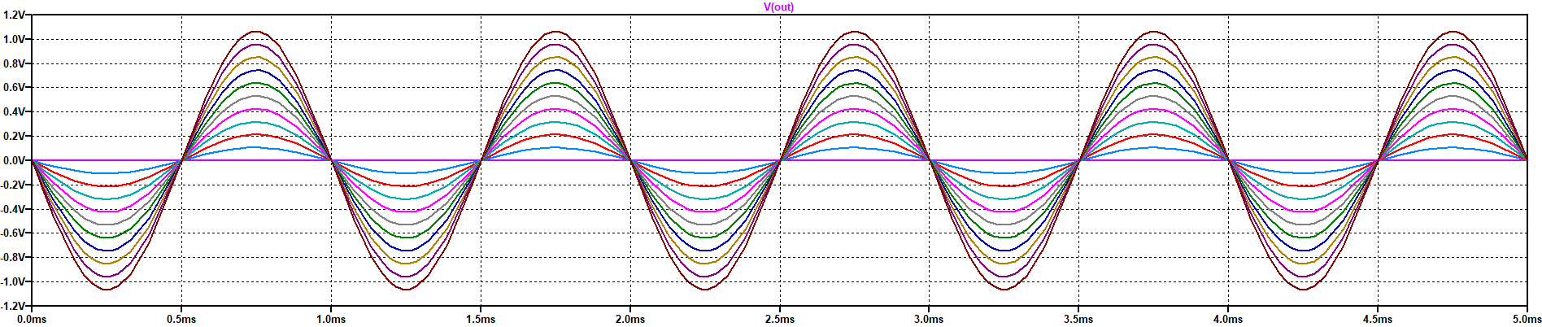
4: The output Voltage transients. the multiple waves represent the output potentiometre incrementing in 1/10ths from fully off to fully on

Revision notes for next iteration
In a future iteration, a transistor-driven LED will be added as a clipping indicator. This circuit will use a 5.6 V Zener diode connected in reverse bias between the op-amp output and ground, with the cathode tied to the signal. When the output voltage exceeds approximately 6.2 V (the sum of the Zener voltage and the base-emitter threshold), the Zener will conduct and activate an NPN transistor such as a 2N3904. This transistor will then allow current to flow from the 9 V rail through an LED and a 1 kΩ resistor to ground, lighting the LED. This indicator will provide a visual cue when the output is approaching the TL072’s clipping threshold (~7.5 V), offering an early warning without significantly loading the signal path.

^ might create a clipper circuit using Zener diodes to protect headphones and OP Amps.
Bill of Materials
Item Name |  | Value | Provider Model | Price (inc) | Total (inc) | Provider
2 x | METAL FILM RESISTOR - 10k | 10K | RESN0058 | $0.10 | $0.20 | PPA
1 x | METAL FILM RESISTOR - 1M | 1MEG | RESN0090 | $0.10 | $0.10 | PPA
1 x | METAL FILM RESISTOR - 470k | 470K | RESN0085 | $0.10 | $0.10 | PPA
1 x | METAL FILM RESISTOR - 100ohm | 100 | RESN0028 | $0.10 | $0.10 | PPA
1 x | 9mm POT PCB - 10K LINEAR | 10K | PT090001 | $2.70 | $2.70 | PPA
1 x | 9mm POT PCB - 1M LINEAR | 1M | PT090019 | $2.70 | $2.70 | PPA
1 x | NICHICON UMA ELECTROLYTIC CAPACITOR - 10uf | 10uf | CAPN0194 | $0.30 | $0.30 | PPA
1 x | NICHICON UMA ELECTROLYTIC CAPACITOR - 3.3uf | 3.3uf | CAPN0192 | $0.30 | $0.30 | PPA
1 x | RUBYCON YXJ ELECTROLYTIC CAPACITOR - 100uf | 100uf | CAPN0217 | $0.30 | $0.30 | PPA
1 x | TL072 DUAL OPAMP |  | ICSN0026 | $1.50 | $1.50 | PPA
1 x | IC SOCKET - DIL 8 WAY |  | CNPC0001 | $0.40 | $0.40 | PPA
1 x | 5mm LED WATERCLEAR - GREEN |  | LD5M0002 | $0.20 | $0.20 | PPA
2 x | EST MONO COMPACT SOCKET |  | CNPH0021 | $4.00 | $8.00 | PPA
1 x | COMPACT 2.1mm DC PANEL MOUNT SOCKET |  | CNDC0012 | $1.00 | $1.00 | PPA
1 x | SPST MINIATURE TOGGLE SWITCH |  | SWTS0009 | $2.20 | $2.20 | PPA
1 x | 3mm FLUSH MOUNT PLASTIC LED HOLDER - BLACK |  | LDBZ0001 | $0.20 | $0.20 | PPA
1 x | ALUMINIUM KNURLED KNOB - RED |  | KNAL0006 | $3.50 | $3.50 | PPA
1 x | ALUMINIUM KNURLED KNOB - BLUE |  | KNAL0008 | $3.50 | $3.50 | PPA
 | Date Ordered: Sunday 22 June, 2025 |  |  | Total: | $27.30
*PPA provider is online at www.pedalpartsaustralia.com

